FSU-Jena
Historisches Institut
Ü Transformation in the USA 1880-1920
Prof. Ann Stamp-Miller
WS 05/06
Jason D. Smith
28 June, 2006

Creating by Doing:
The Invention and Innovation of
Unusual Truss Bridges in the United States
1850-1930

Introduction:

Every great engineer was once a beginner. During the late 1800s, a toy company A.C. Gilbert and Co. invented a new toy especially made for engineers called the Erector Set. Consisting of steel beams, nuts and bolts to connect them, as well as other components, children who received an Erector Set spent hours upon hours building various structures they could even imagine, whether it was a replica of the Eiffel Tower, the Eads Bridge, or the first skyscrapers dominating Chicago. Little did they realize that many of these owners of the Erector set would later become some of the most renowned engineers in the country. Although it would be naïve to say that every boy who received an Erector set would later become an engineer, as was mentioned by A.C. Gilbert, but it was clear that the number of engineers in the United States had skyrocketed since 1850, when the number was at 512. By 1900, over 45,000 engineers were in business, designing and building skyscrapers, houses, and especially truss bridges (see figure 1.) This leads to the question of the popularity of truss bridges during that time. What was so special about the construction of truss bridges?
Many bridge engineers followed the basic concepts of building Pratt, Howe, Warren, and Bowstring Arch bridges and their variants, with some of them decorated them with ornamental designs located on end posts and portal bracings. To show their pride in their bridge design, many engineers constructed plaques on the bridge, as a way of leaving their mark and allowing future historians and engineers to document the information on the bridge’s significance for various governmental organisations dealing with architectural history, like the National Register of Historic Places, and HABS/HAER. But other engineers of this time managed to create, patent, and even construct a number of unusual truss bridges. Such designs, like the Thacher, Kellogg, and Greiner trusses broke the basic standards of truss bridge construction and were discouraged by many bridge companies as being absurd and not living up to the standards that were set forth during that time,. Despite the critics, many of the engineers and bridge companies went ahead and experimented with them anyway, for reasons of breaking away from the standards set forth by the engineers and the state and federal governments, as well as cutting costs on the
amount of metal and wood used for truss bridge construction. In the long term, some of these structures withstood the test of time, and are now preserved as artifacts of American History.
This essay will focus on these unusual bridge types, how the engineers patented and constructed them, and why these designs are an important aspect in American (engineering) history. It will start off with an explanation about the popularity of the Pratt and Howe truss bridges, followed by the introduction of various forms of suspension truss bridges (including the Fink and Bollmann designs), the A-frame designs (including the Thacher design) and ending at the popularity of Warren trusses from 1910 on. It will also feature some other unusual trusses that were designed and constructed (especially those stemming from the Bowstring and Lenticular truss designs), followed by an explanation of why many of these trusses can seldomly be found nowadays, as many of these unusual designs were replaced with the standardized truss and later concrete designs.

Pratt and Howe Trusses:
The Pratt and Howe truss bridge designs are two of the oldest known bridge designs that were developed in the 1800s, behind the variants of the Town Lattice design, as well as the king and queen post designs (see figure 2). William Howe designed and patented his truss bridge in 1840, using timber and wrought iron designs. The Howe truss consisted of diagonal beams being slanted upwards per panel, going towards the middle of the bridge’s span. That means at the beginning of each panel, the diagonal beams start at the bottom where the vertical and horizontal beams meet and end at the top chord at the next vertical beam. The Pratt design, created in 1844 by Thomas and Caleb Pratt represented the exact opposite design, where the diagonal beams start at the upper chord and vertical post and end at the bottom at the next (see figure 3). Unlike the Howe design, the Pratt design was used for longer spans and it resulted in the alteration of the design by many other engineers, some of which were used quite often for the construction of longer spans. While the double and triple-intersecting Pratt designs were based on the designs patented by Squire Whipple, the Baltimore Petit represented sub-divided bracings for the Pratt design. Other engineers created curved-like polygonal designs, whose purpose was to reduce the tension on the upper chords, like the straight-line designs. This includes the Camelback, Parker, and Pennsylvania-Petit trusses (see figure 4). Like the Pratt and Howe, these variant truss designs were dominant in bridge construction during their heydays, and many of these examples can still be seen today on many American roads. These designs also became the scope of some unusual design concoctions, some of which will be discussed below.
Pegram Truss:
One of the main factors that many bridge engineers were worried about was the amount of steel being used in bridge construction, let alone the ability to assemble, and reassemble bridges without having to pay to fabricate the exact bridge span. George H. Pegram (1855-1937) found a way to recycle the bridges through his invention of the Pegram Truss. Born in Council Bluffs, Iowa, Pegram graduated from Washington University in St. Louis in 1877 and began his career as an engineer at the Utah and Northern Railroad, which planned to expand its rail line from its headquarters in Odgen to Montana, Wyoming, and Portland, Oregon. He later became chief engineer of the Edge Moor Iron Co. in Wilmington, Delaware from
1880-89. During his tenure at the company, he patented his own unique truss design in 1885. It consisted of a Parker design with vertical posts leaning towards the center, usually at an angle of between 60 and 75°. The diagonal posts would support the leaning posts like it would, had it been a Pratt or Parker design (see figure 5). When he introduced the model in Engineering News in 1887, Pegram hoped that his design would solve the problems involving bridge (re-) assembly. His first bridge this type was constructed over the Verdigris River in what is now Oklahoma in 1889. Afterwards, his Pegram truss types popped up everywhere throughout the western part of the US. This included the construction of 20 Pegram truss bridges in 1890 alone, when Pegram was a bridge engineer for Missouri Pacific Railroad. During his tenure at the MPRR, he constructed over 100 Pegram truss bridges in Kansas, Missouri, Colorado, and especially Idaho, where he concentrated most of his time in his bridge construction. His rise to fame was completed in 1890 with the construction of the 700 ft. x 600 ft. Union Station in St. Louis, using his truss design. He later became chief engineer at Union Pacific Railroad from 1890 until 1898 when he moved to New York City and spent the rest of his life there. At the time of his death in 1937, Pegram left behind an engineering legacy which can be seen to this day with his Pegram truss design. Although no longer used, his engineering works using this model can still be seen today, especially in Idaho, where seven of his bridges, including a deck truss bridge over Conant Creek are still standing. Even a town in Idaho was named in his honor.

Kellogg Truss:
When the first Pratt and Howe truss bridges came out in the 1840s, they were constructed mainly of iron and wood, for they were both plentiful in the construction of bridges during that time. However in 1870, Charles Kellogg noticed a flaw in the Pratt and Howe structures which needed to be dealt with before any bridge-related accidents could happen. As the industrial age progressed in the United States, the expansion of the railroads and highways also took place, and with that, the innovation of trains and wagons, designed to carry heavier loads. This led to some problems with the Pratt and Howe truss structures’ inability to withstand the tension that on the lower chord. Because steel had not yet replaced iron and wood, Kellogg introduced an alternative Pratt design in 1870, designed to add additional support to the bottom chord. The Kellogg truss consisted of subdivided diagonal beams which the start at the upper chord and end at two different locations: the first one at the vertical post forming a 45° angle, and the second between the two vertical posts of the panel forming a 60° angle. (see figure 6) According to Kellogg, this design was supposed to be better than the Howe design. Unfortunately, other engineers dismissed the design as being inadequate for bridge construction. Even J.A.L. Waddel, who designed his own type of bridge in the 1880s, considered Kellogg’s design “a freak.” Nevertheless, Kellogg, along with other engineers constructed a few Kellogg truss bridges, mainly in the north-eastern part of the US, where he originated. Sadly, the introduction of steel led to the construction of heavier bridges, using the standardized Pratt and Warren truss designs and leading to the demise of the Kellogg truss bridge. Only one Kellogg truss bridge was discovered near Liberty Falls, NY, but it is unclear whether this bridge still exists today, let alone if other Kellogg truss bridges still exist in the country. Fortunately though, through thorough research and bridge hunting, chances are there might be some more Kellogg truss bridges found elsewhere.

Stearns truss:
Another truss bridge type that was used very little but whose lone structure can still be seen today is the Stearns truss. Patented by William Stearns in 1890 and published in the Engineering News in 1892, the Stearns truss bridge represents a rather unique design which is a cross between the Kellogg, Howe, and Pratt trusses. The bridge type consists of two diagonal chords that start at the top chord at the end post and then proceeds to connect at the vertical post in a 45° angle, as well as at the bottom chord between the end post and the vertical post in a 60° angle, just like the Kellogg truss bridge. However, at the center panel of the truss structure, the diagonal chords meets just like at the end spans, creating a pattern of an X crossing a V (see figure 7). A similar design was attempted by Frank Leers some years earlier, but it was unsuccessful. Like Kellogg, Stearns was concerned with the increasing loading capacity of the truss bridges combined with resources that were available to construct them. However, Stearns was able to persuade some of the bridge contractors of the cost-effectiveness of building a light-weight bridge, using his truss design. Although he spent his entire career working at Berlin Iron Bridge Company in Massachusetts, it is unclear whether or not the bridge company constructed any of the Stearns truss bridges, and if so how many. It can be said though that other bridge companies adopted the Stearns model for their bridge construction, as was the case with the Winamac Bridge Co. in Indiana, which constructed a Stearns truss bridge over Big Monon Ditch in Pulaski Co., IN in 1905. According to the research that has been done so far, this bridge is the last of its kind in the US. Currently, it is being refurbished and relocated to Delphi, where it will be incorporated into the bike trail network spanning the Wabash-Erie Canal. It is unknown when the bridge will be rebuilt, but it is clear that the structure will span the Wabash-Erie Canal near a restaurant at the north end of town.

Fink truss:
The period of Industrialization combined with the proliferation of bridge construction in the United States attracted various engineers from Europe, who earned their degrees at the universities in their native lands but decided to take their chances in the United States and establish their reputations as well-known engineers. Many of the engineers who immigrated to the United States came either from Germany or the Austro-Hungarian Empire, where conditions there were not favourable for a successful career there. One of those engineers who started his career as an engineer in the US was Albert Fink. Born in Frankfurt/Main, Germany in 1827, he emigrated to the United States in 1849, one year after receiving his engineering degree at the Polytechnic University in Darmstadt. After immigrating to the US, he started his career at the Baltimore and Ohio Railroad (B&O) before switching to the Louisville and Nashville Railroad in 1857, where he spent 20 years at the company. Apart from building new bridges, Fink repaired and rebuilt various bridges that had been destroyed during the Civil War before being elected Vice President of the company in 1870. He left the company to move to New York in 1877 to work together with some of the famous railroad entrepreneurs on building bridges and other architectural works, including The Vanderbilts and New York Central, The Carnegies and Penn Central, and Thomas Scott and Union Pacific.
During his career as bridge engineer, he developed his own truss type, where the main diagonal beams start at the upper chord at the end post and each of the main diagonal beams would meet a vertical post at the bottom chord going towards the center span, beginning with the longest one meeting at the middle vertical post. Secondary diagonal beams would be used to construct an A-frame design, which starts at the top
chord at a vertical post and end at the bottom chord between two vertical posts at a 60° angle (see figure 8). Fink constructed hundreds of various deck and overhead truss bridges using his design during his career as an engineer between the time he patented his design in 1854 and the time he moved to New York in 1877. Of the truss bridges that were built during his career, only two of the Fink truss bridges still exist today: a deck Fink truss bridge in Lynchburg, Virginia (which is now located at a city park)., and a 105 ft. long Fink through truss bridge spanning Conotton Creek in Ohio, also known as the Zoarville Station Bridge. A similar Fink through truss bridge also existed near Hamden, New Jersey, but was destroyed in an automobile accident in 1978. The 100-foot long span was disassembled and is now awaiting reassembly at an undisclosed location.

Bollmann truss:
Fink’s design of the truss bridge represented a fine example of the innovation of the “suspension truss” design, which consisted of the center span being supported by main diagonal beams which started from both ends of the truss bridge, where the end post and upper chords meet. However, Albert Fink was not the person who directly invented this suspension truss design. The grandfather of the suspension truss bridge design happened to be another German engineer, Wendell A. Bollmann. Born to German immigrants in Baltimore, Maryland in 1814, Bollmann spent his entire life in this region, working first as a carpenter then later as a civil engineer. He spent most of his career with the B&O, constructing various suspension truss bridges, starting with the first one at Savage, Maryland in 1850. Consisting of diagonal beams which each one meets the bottom end of the vertical post going all the way across the bridge, Bollmann constructed over 100 of his bridges in the eastern half of the United States, including a six-span 435’ long Bollmann truss bridge over Quincy Bay near Quincy, Illinois in 1867-68 and an incredible 28-span Bollmann deck truss bridge near Parkersburg, PA in 1871 (See figure 9). The last Bollmann truss bridge erected consists of two 76’ spans over the Little Patuenx River in Savage, Maryland. Although it was built at a different location in 1869, the B&O moved the two spans to Savage in 1888, replacing the 1850 span which was removed earlier for undisclosed reasons. The bridge remained in service until the B&O abandoned the line in 1915, just 31 years after Bollmann’s death in Baltimore. That bridge was rediscovered in the 1960s and was remodelled in 1983-84. Still sitting at its original location but now used as a bike trail, the Bollmann bridge in Savage represents the last of the suspension truss bridge designed and built by Bollmann.

Greiner truss:
In 1894, just six years after the last Bollmann truss bridge was erected in Maryland, another B&O bridge engineer, John Greiner (1859- 1942) designed and patented another type of suspension truss design, known as the Greiner truss. Like the Bollmann and Fink trusses, Greiner’s truss design consisted of diagonal beams starting at both ends of the bridge at the top chords. However, unlike the two designs, the diagonal beams create an introverted pattern where it curves towards the bottom of the center vertical post before moving back up to the top of the end post of the bridge. As the diagonal beam makes its introverted pattern, it is supported by secondary diagonal beams which start at the top of the center vertical post and they meet the introverted diagonal beam at the vertical posts going outwards, a design similar to the Howe truss bridge (See figure 10). The motive towards constructing such a design was Greiner’s attempts of building truss bridges using old railroad tracks and previous trusses while at the same time, trying to find constructive ways of designing a bridge, which could withstand the tension on the bottom chords, especially when carrying heavier loads across the bridge. He used various Howe and Bowstring configurations to find the right design to meet these two goals. Like the Kellogg truss design, the Greiner truss design was played down by many engineers who believed that this symmetrical design was unfit to be used for traffic. Although many of Greiner’s trusses were built by the B&O, spanning the railroad tracks carrying county roads, only one is reported to be still standing to this day- a newly remodelled Greiner truss bridge in St. Augustine, Florida. However, it is unclear whether or not any more of these bridges still exist to this day.
Greiner was not alone with his attempts of constructing an introverted truss bridge. A previous introverted Bowstring truss bridge was constructed ten years earlier near Lancaster, Ohio by a local bridge company, during the time the usage of iron for the Bowstring truss bridges was still popular. Unlike the Greiner truss bridge, this introverted Bowstring truss design was patented by William Black in 1875 and consisted of a Lattice design, similar to the Bowstring truss design patented by Squire Whipple in 1848, but constructed in an introverted but symmetrical fashion. This bridge is the last of its kind standing in the United States, and is now located on the campus of Ohio University in Lancaster.

Lane and Miller-Borcharding trusses:
While Greiner later established one of the oldest engineering firms still in existence (URS Greiner Woodward Clyde in Baltimore), another engineer, Daniel Lane patented another truss design using old railroad and trolley tracks. Between 1890 and 1901 the Lane Bridge Works Company constructed single span Howe truss bridge designs, using old rails which were reformed and clamped together by bolts that were once used for laying the track. These rods were to represent the upper and lower chord of the design, pinned together by nuts and bolts by just simply inserting the bolts through the rails and screwing the nut on afterward. This made the disassembling and reassembling of the truss design a lot easier. This design was to be a Howe truss configuration but with three panels with the center span consisting of an A-frame design. Many of the trusses constructed during Lane’s tenure were no longer than 100 ft. in length. While many of these Lane pony trusses became popular at the turn of the century, one can only find two existing Lane trusses today: a 30 ft. long structure near Mc Dowell, Virginia built in 1896, and a 90 ft. long Park’s Gap Bridge near Martinsburg, West Virginia, built two years earlier. While the McDowell bridge has been preserved for a bike trail, the other bridge’s future is yet to be determined as the structure is slated to be replaced soon.
While the Lane truss bridge was phased out after 1901, another company in Missouri, the Miller and Borchering Bridge Builders of St. Louis altered the Lane design by adding vertical beams which start at the lower chord and vertical post and end at the center of the end post at a 90° angle. Many of these bridges were constructed during the 1910s and 20s in Missouri, with many of them located in Butler County. But unlike the Lane truss, the Miller-Borchering pony truss design were fabricated using steel, just like with the original designs of the Pratt, Warren, and Howe designs that were being constructed during this time, and the joints were riveted, meaning the beams could be slid and molded together (See figure 11). Eight of these bridges still exist today, with three of them still being used for traffic. This includes two in Butler County: a 39-ft. structure spanning Pike Creek south of Poplar Bluff, and an unusual 219-ft. two-span structure supported by a steel tower in the middle of the river west of Poplar Bluff, also known as the Hargrove Bridge. While the 1917 Hargrove Bridge has been preserved for lighter traffic, other bridges of its kind, including the 39 ft. structure built in 1920 are quickly being replaced before there is a chance to visit, document, and preserve them.

Thacher truss:
Albert Fink looked up to Wendell Bollmann for guidance in constructing suspension truss designs while the designers of the Lane and Miller-Borchering truss bridges may have looked up to and attempted to construct bridges using the A-frame model created by another bridge engineer: Edwin Thacher (1840-1920). A graduate of Renesselaer Polytechnic Institute, Thacher began his career right away as a civil engineer, working first at Keystone Bridge Co. in Pittsburgh before moving to Canton, Ohio to work at Wrought Iron Bridge Co. He later established the Concrete Steel Engineering Co. in New York in 1901, but not before starting two previous firms in Louisville and Detroit. Thacher was known as the inventor of his own designs. He adopted the designs created by the previous bridge inventors and altered them for the purpose of saving costs on the usage of steel but also making sure that the structures were capable of withstanding the increasing traffic load. His Thacher truss design, patented in 1883 and published in the American Society of Civil Engineers journal on 7 November, 1883 was a primary example. Thacher used the examples of the Howe, Pratt, and Fink models and constructed a design which resembled a W shape, like the Warren truss, but the center span would be supported by two primary diagonal beams, shaping itself into the letter A, usually at a 60° angle. Thacher experimented with this design with the construction of the first Thacher truss bridge over the Wasipinicon River in Iowa in 1881, with a span of 147.4 ft. After the patenting of his truss in 1883, Thacher continued to erect these bridges in various spots in the country, including the two-span 313.5 ft. long Costilla Crossing over the Rio Grande in Colorado in 1892, a 133 ft. long Linville Bridge in Virginia in 1898, and the 140 ft. long Niver Road Bridge in Saginaw Co., Michigan in 1889. All of them are still standing. Other companies whom Thacher had no affiliation with also adopted the Thacher truss model to be used in small river crossings, like the King Bridge and Iron Co., in Cleveland, which constructed the Ellsworth Ranch Bridge in Emmet Co., Iowa in 1895 (See figure 12), as well as two 93 foot long spans in Lac Qui Parle Co, Minnesota and Hamlin Co. South Dakota. While the Thacher truss focused mainly on the construction of overhead truss bridges, one could argue that some companies tried to experiment with the Thacher pony truss design, like with the Okoboji Bridge in Iowa, built in 1909 by the Clinton Bridge and Iron Works Co. However, more evidence would be needed to confirm this speculation. It is unclear how many more Thacher truss types are still out there, but it is a well-known fact that when Thacher died in 1920, he built over 1000 various bridges throughout the country, while inventing various other bridge designs which can be seen on America’s highways to this day, including Topeka River Bridge in Kansas (1897), which was the first multi-span reinforced concrete bridge built in the US, and the West Broadway Bridge in Paterson, New Jersey (1897), which comprised of pre-stressed concrete reinforced with steel. This bridge, which was the first of its kind in the US was based on a model that Thacher used that was created by Josef Melan four years earlier. He also was responsible for the six-span Walnut Street Bridge in Chatanooga, Tennessee; a Camelback through truss bridge built in 1891 over the Tennessee River and is now part of the city bike trail network serving the city.

By the 1920s, many of these designs disappeared in place of standardized trusses designed for carrying heavier traffic on the countries major highways. Apart from the Pratt and Howe trusses, the Warren truss design, constructed by James E. Warren in 1848 and consisting of a truss design shaped like the letter W, began to dominate the highways from about 1910 onwards (See figure 13). While the Howe design was eventually restricted to shorter spans (especially for covered bridges) and eventually phased out in light of the railroad bridge accident near Ashtabula, Ohio in 1876, the Pratt, and Warren designs as well as their hybrid designs became dominant on the highways, constructed out of metal and having riveted connections.

Other Unusual Truss Designs:
While Bollmann, Pegram, Thacher, and Fink were successful in implementing their truss designs into praxis by building many structures in the United States, other engineers tried experimenting with other truss designs, which were either not patented or mentioned in any engineering journal, while some were mentioned in the engineering world, but was discouraged to a point where only a few types were built. But nonetheless, many of the engineers went on and experimented with the bridge designs against the will of the critics, even though the number of bridges were very rare. Even J.A.L. Waddell, an outspoken critic of some of the truss designs like the Kellogg truss, experimented with various truss designs, including his Waddell-A-truss, which will be mentioned below. Here are some examples of the trusses that were constructed and how these were developed.

Waddell-A-Truss: Using the example of the triangular King-post truss design, J.A.L. Waddell in 1893 designed and constructed four bridges using his own design for the Kansas City and Pittsburgh Railroad. His design consisted of a triangular A-frame design with subdivided panelling. His original intention was to construct just the through truss design, for the pony truss design would be more difficult to withstand the tension caused by excessive weight crossing the bridge. However, after 1900 some variants of the Waddell pony truss types popped up across the US, with many of them being used for vehicular traffic. Today, only two of Waddell’s through truss designs and a few of his pony truss designs exist, with a majority of them being used for recreation purposes.

Lenticular Truss Bridge: Using the model of Whipple’s Bowstring Truss design, Edwin Stanley designed and patented the design in 1851, consisting of two vertical endposts, followed by a parabola design, exposing the inner lattice design, and resembling a football sitting above a ravine. The majority of the structures were built between the 1870s and the 1910s by the Berlin Bridge and Iron Company in the heavily populated areas along the East Coast as well as in the metropolitan areas in Texas. Many of these structures are still in tact to this day. This includes the Smithfield Street Bridge in Pittsburgh, designed and built by Gustav Lindenthal in 1883. This two-span 364 ft. long structure was altered twice with the addition of another truss in 1891 and the replacement of the portal bracings in 1915, but still retains its integrity to this day. Other Lenticular bridges worth noting are the Sherwoods Bridge in New York State (which has been removed to a remote location awaiting to be reused), as well as Lover’s Leap Bridge in New Milford, Connecticut, which is being reused for pedestrian and bicyclar traffic. The latter bridge, built in 1888 is listed on the National Register of Historic Places.

Horton Truss: A cross between a Bowstring truss bridge and an inverted Kellogg truss design, Charles Horton in 1897 patented this design consisting of a Bowstring design whose upper chord and vertical posts are supported by two diagonal posts starting at the bottom of each vertical post and ending at the next vertical post and between the vertical posts respectively. Another design that was typical of Horton’s design was the Bowstring truss’s endpost curving into a vertical position as it is connected to the truss foundation. Five of these truss bridges exist today at the Van Loon Wildlife Refuge outside LaCrosse, Wisconsin.

K-Truss Bridge: At the beginning of the 19th century, another variant of the Parker design began to take shape. Used for overhead truss bridge design, the K-truss bridge consisted of two diagonal beams which start at each end of one vertical post and end at the middle of the next post, going towards the center of the bridge. These bridges could be built with the diagonals going inwards towards the span or going outwards towards the span. Some of the K-trusses were constructed throughout the United States in places like Vermont, Pennsylvania, and Maryland. However, as the settlers moved westward, engineers began using K-trusses for longer spans in the south-western part of the US, in places like New Mexico and Oklahoma. To this day, it is unknown how many of these K-trusses still exist in the United States, but in Oklahoma, as many as 28 K-trusses have been spotted and documented, with the majority of these structures being built from the 1920s onward.

Others: Other engineers took fame in constructing individual bridges, whose designs did not coincide with the designs that were already patented. Horace E. Horton, for example, constructed a wrought iron Warren Bridge over a lake in Oronoco, Minnesota in 1876, using a combination through truss and deck-arch design. At the end of the 19th century, a railroad bridge spanning the Big Sioux River in South Dakota was constructed for the Dakota and Southern Railroad Co, comprising of two Pratt deck truss designs whose vertical posts were slanted inwards like that of the Pegram truss bridge design. Many bridge companies used an additional truss or arch design to their truss bridge to add extra support for increasing traffic. This “double-design” approach made the bridge’s outer appearance look very unique. Some examples of those can be found in Pennsylvania, including the 7th Street Bridge in Coudersport, and the Mead Avenue Bridge in Meadeville. As for some engineers, they even stretched their creativity further by constructing original truss bridges but consisting of approaches that started in a curved fashion, thus making travelling across the bridge quite a challenge. While the Oil City Railroad Crossing in Pennsylvania consists of two approaches that split off in a Y-shape design after crossing Parker truss design, the Hastings Spiral Bridge in Minnesota represented one of the most unusual truss designs ever built in the country. Built in 1895, the bridge is unique for its curly-Q north approach, that the driver had to endure before crossing the main span- a Pennsylvania Petit overlooking the Mississippi. It was the only bridge of that kind built in the country during that time. Sadly, these bridges either no longer exist or are being slated for replacement, and the only way a historian can look at the bridges now are in photographs and books.

Conclusion:
The invention, patenting and construction of truss bridges between 1850 and 1930 can best be described in three different streams of development: invention, alteration, and proliferation. Invention meant that bridge engineers used their creative thinking in constructing a truss bridge design suitable for traffic and in many cases affordable to assemble and reassemble. Alteration meant that many engineers adopted the truss designs that were created by previous engineers and altered them to their advantage for the reasons already stated under invention. Proliferation meant that many of the engineers fought with other engineers to standardize their truss design for vehicular traffic, thus pushing other promising designs off to the side and eventually into the garbage can. While the Pratt, Howe, Town, and later Warren designs established a foothold in the bridge building industry, other truss bridge designs like the ones mentioned in this essay managed to receive at the very best marginal attention. While some of the truss types, like the Bollmann, Pegram, Fink, and Waddell trusses received some exceptional attention, others like the Greiner, Kellogg, K-truss, and the Horton Bowstring trusses were simply ignored because of their engineering infeasibility. Through defiance and their creative thinking, the engineers constructed the truss designs to their liking, and though some of the truss bridges, like the Dell Rapids Railroad Truss Bridge, the Hastings Spiral Bridge and the Horton Bridge near Oronoco no longer exist, other unusual bridge designs, like the Stearns and Horton Bowstring Arch bridges can still be seen today. While many of the unusual bridge designs have been preserved as places of historic interest related to 19th and 20th century archaeological technology in the United States, historians, engineers, and communities are struggling to preserve what is left of this American architectural history, before they succumb to plain and boring concrete bridges and eventually modernization. As Eric Delony mentioned in a recent interview with the archaeological society newspaper TICCIH in 2004:

In the US, recent statistics suggest that half, if not more, of America’s historic bridges have been lost in the last twenty years - two decades in which transportation and preservation consciousness was at the highest level. This is an alarming and sobering statistic.

Modernization can mean building something new, but it should also include preserving the past for future generations to see them- not just the plagues, photos, and literature, but the structure itself.

Truss Bridge Designs:

Figure 1.: Truss bridge description:

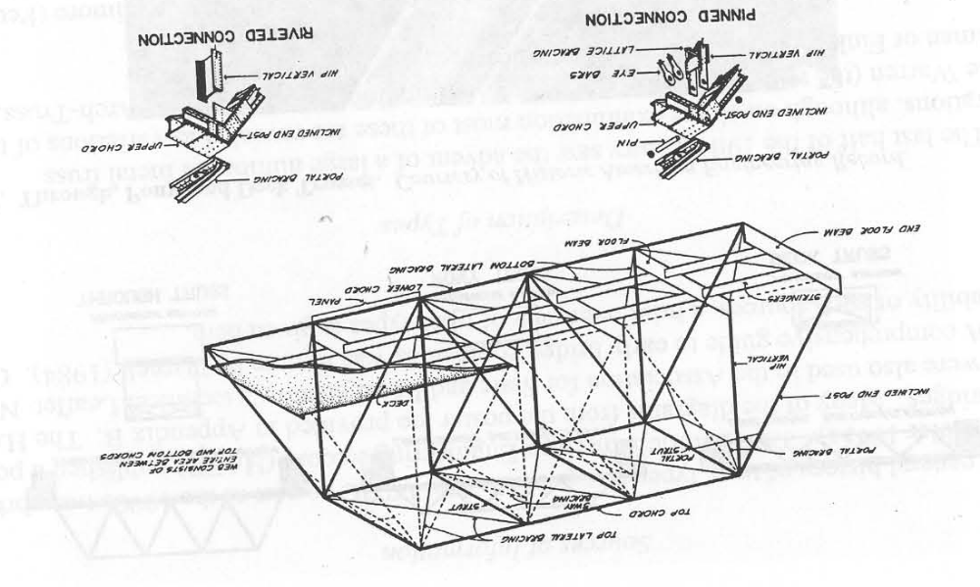

Figure 2. Town Lattice, King, and Queen Post Design:

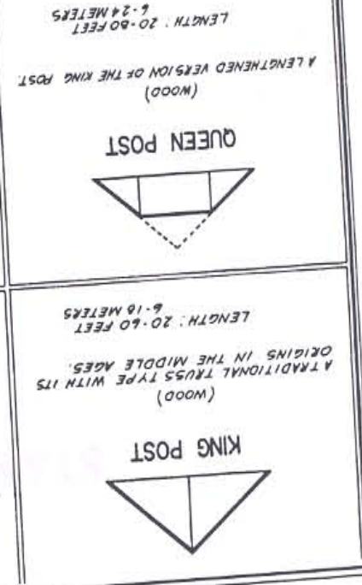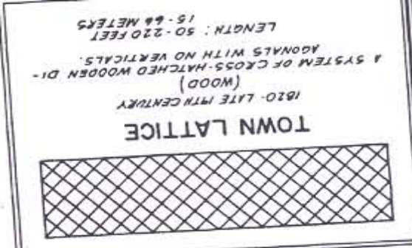

Figure 3. The Pratt and Howe designs: The first popular truss types constructed in the 1800s.

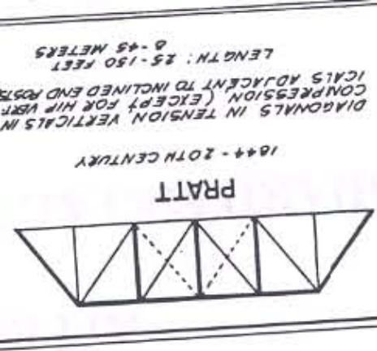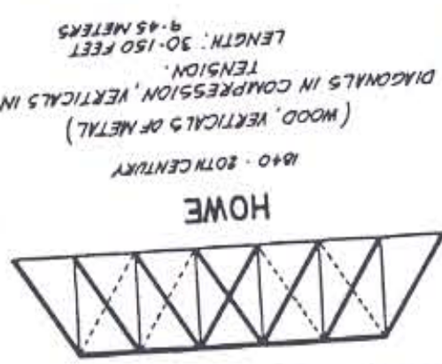

Figure 4. The variants of the Pratt and Howe designs: Parker, Camelback, Baltimore, and Pennsylvania Petite

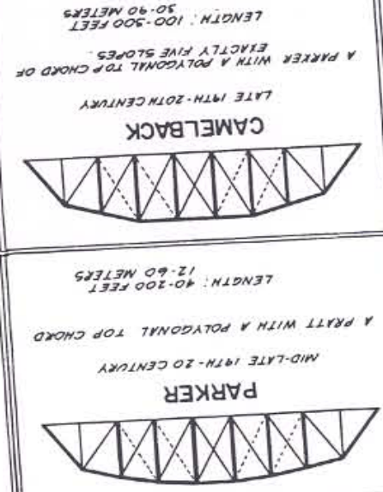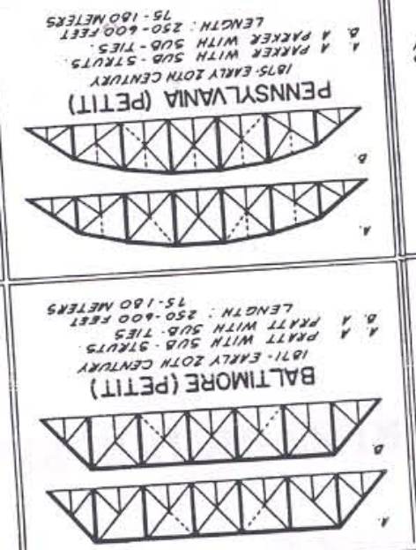

Figure 5. The Pegram Truss Design:

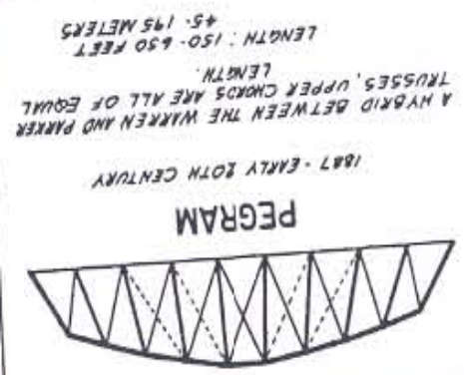

Figure 6. The Kellogg Truss Design:
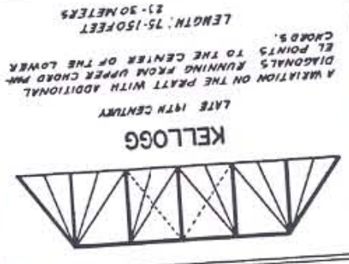

Figure 7. The Stearns Truss Design:

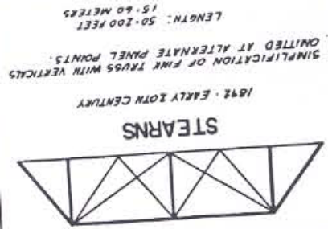

Figure 8. The Fink Truss Design:

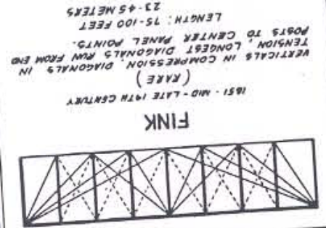

Figure 9. The Bollmann Truss Design:

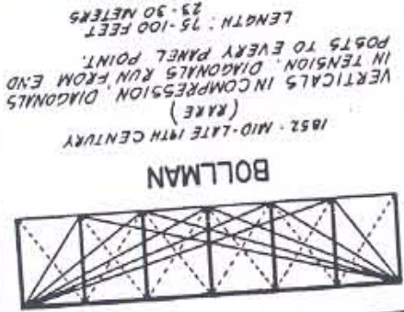

Figure 10: The Greiner Truss Design

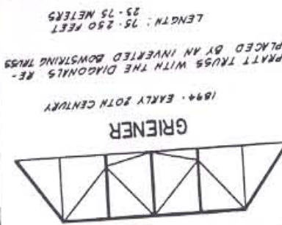

Figure 11: The Miller-Borcherding Truss Design- Pike Creek Bridge S of Poplar Bluff

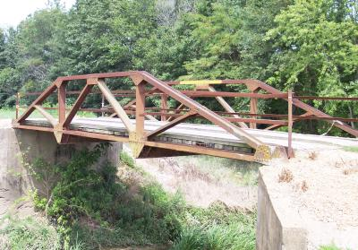

Figure 12: A Variant of the Thacher Truss Design- Photo of the Ellsworth Ranch Bridge in Iowa

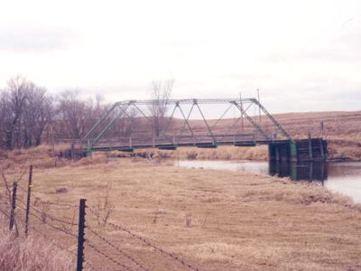

Figure 13: The Warren Truss Design- Popular after 1910 (in most areas of the country)

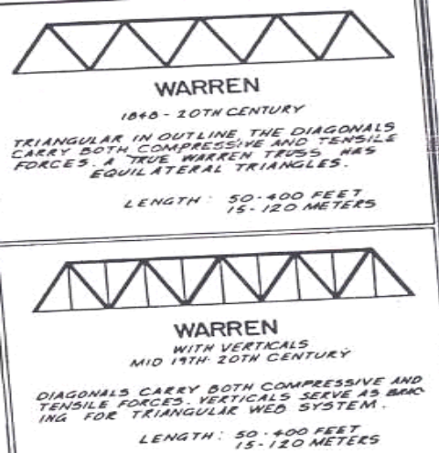

Diagram courtesy of the Historic American Engineering Record/National Park Service
Photos courtesy of the Historic Bridges of the Midwest Website.
Bibliography:

American Society of Civil Engineers Online. Available at www.asce.org/history/brdg_finkdeck.html

Bauer, Steve. Interview on 26 June, 2006.

Baughn, James. Interview via e-mail on 13 February, 2006

Bridge Diagram. Historic American Engineering Record/National Park Service

Bollmann Truss Railroad Bridge. National Historic Landmark Nomination by the National Register of Historic Places. (NRHP-Bollmann) Documented in August, 1986

Camp Tuscazoar Online. Available at www.tuscazoar.org/TLpageBIG.htm

Deibler, Dan Grove. Metal Truss Bridges in Virginia: 1865-1932 Charlottesville, VA: Virginia Transportation and Research Council, May, 1975

Delony, Eric. „Replacement/Rehabilitation of Old Bridges?“ TICCIH Journal No. 28, Spring, 2005

Disappearing Bridges Website. Available at: http://www.venangoil.com/Bridges.html

Edited Appletons Encyclopedia Online. Available at www.famousamericans.net

Guise, David. Elusive American Truss Bridges: The Dell Rapids Truss Society for Industrial Archeology, Vol. 31 Nos. 3-4, 2002

Guise, David. Elusive American Truss Bridges: Greiner Truss: Bridge of Rails Society of Industrial Architecture, Vol. 29 Nos. 3-4, 2000

Guise, David. Elusive American Truss Bridges: Horton’s Bowstring Truss Society for Industrial Archeology, Vol. 31, No. 2, 2002

Guise, David. Elusive American Truss Bridges: Kellogg Truss Society of Industrial Architecture, Vol. 28, Nr. 4, Winter, 1999

Guise, David. Elusive American Truss Bridges: Stearns Truss Society for Industrial Archeology, Vol. 29, No. 1, 2000

Historic Bridges of Cleveland. Cleveland University Online. Available at www.cu.edu.

Historic Bridges of Connecticut Website. Available at www.past-inc.org/historic-bridges

Historic Bridges of Iowa Website Available at http://www.ole.dot.state.ia.us/historicbridge/

Historic Bridges of the Midwest Website. Available at http://bridges.midwestplaces.com

Historic Bridges of Minneapolis-St. Paul Online. Available at www.vici.com.

Historic Bridges of Oklahoma Online. Available at http://okbridges.wkinsler.com.

Jackson, Donald C. Great American Bridges and Dams New York, et al.: John Whiley and Sons, 1988

Jackson, Donald C. The Thacher Truss Society of Industrial Archeology Newsletter, January-March, 1979

John Bright Bridge No. 1. Historic American Building Record. HAER OH-44. Documented in Summer, 1986

Lane Truss Documentation. West Virginia University Institute for the History of Technology and Industrial Archeology Online. Available at : www.as.wvu.edu/ithia/IA_Lane%20Truss%Documentation%20Project.htm.

Miller, Ann L. A Survey of Historic Bridges in Virginia. Charlottesville, VA: Virginia Transportation and Research Council, 1996

Minnesota Historic Society Online. Available at www.mhs.org.

Oil City Y-Bridge. Historic American Engineering Record No. PA-22 Documented in 1971

Okoboji Bridge. Historic American Engineering Record No. IA-40. Documented in 1992

Thacher, Edwin. Transactions: Description of a Combined Triangular and Suspension Bridge Truss, and Comparison of ist Cost with that of the Warren, Pratt, Whipple, and Howe Trusses. American Society of Civil Engineers, 7 November, 1883

Tichi, Cecelia. Shifting Gears: Technology, Literature Culture in Modernist America Chapel Hill, NC: University of North Carolina Press, 1987

Wabash and Erie Canal Website. Available at www.wabashanderiecanal.org

Waddell “A” Truss Bridge: Historic American Engineering Record HAER MO-8 Documented at an unknown date

Watts, Donald W. Mr Pegram’s Bridges: Engineering Legacies in Idaho. Journal of the West, January, 1992

West Broadway Bridge Paterson, NJ. New Jersey Department of Transportation Historic Bridge Data. Documented on 12 November, 2002

Wilson, Pete. Interview via e-mail on 14 December, 2005

Wheeler, Keith. “The Old West: Railroaders” New York: Time-Life Books, 1973

Tichi, Cecelia. „Shifting Gears: Technology, Literature Culture in Modernist America“ Chapel Hill, NC: University of North Carolina Press, 1987, p. 102-4
Ibid, p. 104
Note: HABS/HAER stands for the Historic American Builders Society and the Historic American Engineering Record, part of the National Register of Historic Places and the National Park Service.
Note: The Town Lattice design was patented by Ithel Town in 1820 and consisted of a truss design depicting an rhombus/ X pattern. See figure for a better description.
Deibler, Dan Grove. „Metal Truss Bridges in Virginia: 1865-1932“ Charlottesville, VA: Virginia Transportation and Research Council, May, 1975, p. 11.
Ibid.
Jackson, Donald C. “Great American Bridges and Dams” New York, et al.: John Whiley and Sons, 1988, p. 24
Note: There were some longer Howe truss bridges that were built during the 1850s and 60s. However, after the train wreck at Atashbula, Ohio in 1876, they were restricted to only shorter spans, and they were eventually phased out altogether in the early 1900s.
Historic Bridges of Michigan and Elsewhere Online. Available at www.historicbridges.org. While there are quite a few double-intersecting Pratt and Baltimore truss bridges still standing in the United States, the 1878 Laugherty Creek Bridge, in Dearborn County, Indiana is the only triple-intersection Pratt through truss bridge remaining in the country.
Ibid., p. 24-7.
Watts, Donald W. “Mr Pegram’s Bridges: Engineering Legacies in Idaho.” Journal of the West, January, 1992, p. 79
Ibid., p. 80 Note: The angles of the vertical beams vary per bridge.
Ibid., p. 81-2
Ibid., 82
Ibid., p. 85 Note: He helped city engineers to develope and expand the masit transit system which is still operable to this day. He also was credited for designing the first railroad tunnel spanning the East River between Brooklyn and Manhattan.
Ibid.; Historic Bridges of Michigan and Elsewhere. Note: Pegram chose Nupher from the selection of three towns (Nutria and Wyoming were the other two options) to be renamed in his honor at the time of his retirement. Another Pegram truss bridge worth noting is the 7-Mile Bridge in Preble Co., OH. Built in 1906, this bridge was not built by Pegram, but by the Indiana Bridge Co, in Muncie. There is a possibility that other companies may have adopted the Pegram model for their construction. So far, there has been no connection of Pegram’s business with this or any other bridge company.
Guise, David. „Elusive American Truss Bridges: Kellogg Truss“ Society of Industrial Architecture, Vol. 28, Nr. 4, Winter, 1999, p. 16
Ibid.
Ibid., p. 17 Note: According to Guise, the majority of the Kellogg truss bridges were built in New York State.
Note: According to Guise, a photo of a Kellogg deck truss bridge near Liberty Falls was discovered by James Stewart of the New York Public Library. But it is unknown whether this bridge still exists to this day, for there has been no record of this bridge or any Kellogg truss bridges existing in New York State today. Please see SIA Newsletter V. 32 No. 4, 2003 for more details on the Liberty Falls bridge.
Guise, David. „Elusive American Truss Bridges: Stearns Truss” Society for Industrial Archeology, Vol. 29, No. 1, 2000, p. 14.
Ibid.
Ibid., p. 15
Ibid.
Wabash and Erie Canal Website. Available at www.wabashanderiecanal.org. Note: At the time of this writing, the bridge is currently being disassembled. It will be transported to Caroll, where sections of the bridge will be sandblasted and refurbished, before reassembling it at the above-mentioned location in Delphi.
Edited Appletons Encyclopedia Online. Available at www.famousamericans.net/albertfink/
Ibid., Wheeler, Keith. “The Old West: Railroaders” New York: Time-Life Books, 1973, p. 68. 78,
Miller, Ann B. „Survey of Metal Truss Bridges in Virginia“ Charlottesville, VA: Virginia Transportation and Research Council, 1996, p. 12
Ibid.; American Society of Civil Engineers Online. Available at www.asce.org/history/brdg_finkdeck.html; Camp Tuscazoar Online. Available at www.tuscazoar.org/TLpageBIG.htm. Note: 1. The Fink Deck Truss Bridge in VA was constructed in 1870 for railroad and then later for highway use. 2. The Zoarville Station Bridge was constructed in 1869 for railroad use, before being relocated to Conotton Creek in 1905. This bridge is currently undergoing an extensive renovation process to be reused for pedestrians and bikers.
ASCE Online.
Bollmann Truss Railroad Bridge. National Historic Landmark Nomination by the National Register of Historic Places. (NRHP-Bollmann) Documented in August, 1986, p. 17-18
Ibid., p. 16
Ibid., p. 10-14
Guise, David. „Elusive American Truss Bridges: Greiner Truss: Bridge of Rails” Society of Industrial Architecture, Vol. 29 Nos. 3-4, 2000, p. 12
Ibid.
Thanks to Abba Lichtenstein and the Pontists for providing the information.
Ibid.
Historic Bridges of the Midwest Website. Available at http://bridges.midwestplaces.com; John Bright Bridge No. 1. Historic American Building Record. HAER OH-44. Documented in Summer, 1986. Note: The Hocking Valley Bridge Works constructed this bridge over Poplar Creek near Caroll, OH.
Ibid.
Note: This company was responsible for constructing the Annapolis Bridge, spanning Chesapeake Bay in 1922. This combination of masonry arch bridge with a truss bascule design was later replaced with the current structure in 1995, by the same company that was founded by Greiner. Thanks to Maryland Department of Transportation and the Pontists for the information.
Lane Truss Documentation. West Virginia University Institute for the History of Technology and Industrial Archeology Online. Available at www.as.wvu.edu/ithia/IA_Lane%20Truss%Documentation%20Project.htm.
Ibid.
Ibid; Miller, p. 17
Baughn, James. Interview via E-mail, 13 February, 2006.
Ibid., Historic Bridges of the Midwest Website.
West Broadway Bridge Paterson, NJ. New Jersey Department of Transportation Historic Bridge Data. Documented on 12 November, 2002; Jackson, Donald C. “The Thacher Truss” Society of Industrial Archeology Newsletter, January-March, 1979, p. 9
Thacher, Edwin. Transactions: Description of a Combined Triangular and Suspension Bridge Truss, and Comparison of ist Cost with that of the Warren, Pratt, Whipple, and Howe Trusses. American Society of Civil Engineers, 7 November, 1883, p. 130-2, 160
Jackson (The Thacher Truss), p. 9
Ibid.; Miller, 14; HABS/HAER Inventory: Costilla Crossing Bridge. Documented by Clayton Fraser in 1982 Note: The Costilla Crossing has just been rennovated at the time of this edition, as workers replaced the flooring system and stringers deemed too weak to support the structure. See Historic Bridges of the Midwest Online for details.
Ellsworth Ranch Bridge. Historic Bridges of Iowa Website Available at http://www.ole.dot.state.ia.us/historicbridge/
Yellow Bank Churchground Bridge. Minnesota Historic Society Online. Available at www.mhs.org.; Bauer, Steve, Interview on 26 June, 2006. Note: The Yellow Bank Bridge was relocated to a park located near Hastings, MN in 1996, and was incorporated as part of the Hastings Spiral Bridge replica. For more information, please see the MSP Bridges Homepage under Hastings High Bridge (www.visi.com) or The Little Log House website at www.littleloghouseshow.com.
Okoboji Bridge. Historic American Engineering Record No. IA-40. Documented in 1992; Historic Bridges of Iowa Website. Note: The 1909 truss span was replaced by a prestressed, pretensioned concrete arch bridge in 1929 but was relocated to a point spanning a tributary of the Little Sioux River 13 km west of the new bridge. This bridge stands derelict.
New Jersey Department of Transportation Historic Bridge Data: West Broadway Bridge Paterson, NJ
Jackson (Great American Bridges and Dams), p. 185-6
Historic Bridges of Cleveland. Cleveland University Online. Available at www.cu.edu.
Historic Bridges of the Midwest Online; Minnesota Historical Society Online; Waddell “A” Truss Bridge: Historic American Engineering Record HAER MO-8 Documented at an unknown date. Note: The through types can be found in Missouri and Arkansas, with various pony types being located in places like in Minnesota, where a Waddell-pony type can be found at Schoenemann Park south of Luverne.
Jackson (Great American Bridges and Dams), p. 151-2.
Historic Bridges of Connecticut Online. Available at www.past-inc.org/historic-bridges
Guise, David. „Elusive American Truss Bridges: Horton’s Bowstring Truss” Society for Industrial Archeology, Vol. 31, No. 2, 2002, p. 14-15
Thanks to David Simmons, Eric Delony, and the Pontists for providing this information.
Historic Bridges on Oklahoma Online. Available at http://okbridges.wkinsler.com.
Wilson, Pete. Interview via e-mail on 14 December, 2005 Note: This bridge was replaced with a concrete arch bridge in 1918 and still serves local traffic.
Guise, David. „Elusive American Truss Bridges: The Dell Rapids Truss” Society for Industrial Archeology, Vol. 31 Nos. 3-4, 2002, p. 14
Disappearing Bridges Website. Available at: http://www.venangoil.com/Bridges.html
Ibid; HABS/HAER Bridge Survey Oil City Y-Bridge PA-22
MSP Bridges Online; Disappearing Bridges Website. Note: While the Oil City Railroad Crossing is still in use, the Coudersport and Meadeville crossings are facing a replacement in the near future. The Hastings Spiral Bridge was demolished in the 1950s, shortly after the new bridge, the Hastings High Bridge was opened to traffic. This demolition took place against the will of the protesters who wanted to save the bridge but were unable to put enough funding together to save the structure. However, a replica of the bridge can be found at the Pioneer Heritage Museum south of Hastings (see footnote of Yellow Bank Campground Bridge).
Delony, Eric. „Replacement/Rehabilitation of Old Bridges?“ TICCIH Journal No. 28, Spring, 2005, p. 3
The author of this essay would like to thank the Pontists (which includes Eric Delony, Ann Miller, Abba Lichtenstein, David Simmons among others) as well as James Baughn, and Peter Wilson for their time and efforts in providing some interesting and valuable facts to be included here.

